Practical-2

# Create app for different Intent:-

## activity_main.xml

<?xml version="1.0" encoding="utf-8"?>

<androidx.constraintlayout.widget.ConstraintLayout xmlns:android="[http://schemas.android.com/apk/res/android"](http://schemas.android.com/apk/res/android)

xmlns:app="[http://schemas.android.com/apk/res-auto"](http://schemas.android.com/apk/res-auto) xmlns:tools="[http://schemas.android.com/tools"](http://schemas.android.com/tools) android:layout_width="match_parent" android:layout_height="match_parent" tools:context=".MainActivity">

<Button

android:id="@+id/button" android:layout_width="wrap_content" android:layout_height="wrap_content" android:text="@string/explicit" android:textColor="#37474F" app:backgroundTint="#8BC34A" app:layout_constraintBottom_toBottomOf="parent" app:layout_constraintEnd_toEndOf="parent" app:layout_constraintHorizontal_bias="0.501" app:layout_constraintStart_toStartOf="parent" app:layout_constraintTop_toTopOf="parent" app:layout_constraintVertical_bias="0.316" />

<Button

android:id="@+id/button2" android:layout_width="wrap_content" android:layout_height="wrap_content" android:text="@string/inplicit" android:textColor="#455A64" app:backgroundTint="#CDDC39" app:layout_constraintBottom_toBottomOf="parent" app:layout_constraintEnd_toEndOf="parent" app:layout_constraintStart_toStartOf="parent" app:layout_constraintTop_toBottomOf="@+id/button" />

</androidx.constraintlayout.widget.ConstraintLayout>

## string.xml

<resources>

<string name="app_name">Pract2</string>

<string name="explicit">Explicit</string>

<string name="inplicit">Inplicit</string>

<string name="textview">Welcome to Second Activity</string>

</resources>

## MainActivity.java

package com.example.pract2;

import android.content.Intent; import android.net.Uri; import android.os.Bundle; import android.widget.Button;

import androidx.appcompat.app.AppCompatActivity; public class MainActivity extends AppCompatActivity {

@Override

protected void onCreate(Bundle savedInstanceState) { super.onCreate(savedInstanceState); setContentView(R.layout.activity_main);

Button b1 = findViewById(R.id.button); Button b2 = findViewById(R.id.button2); b1.setOnClickListener(v -> {

Intent i=new Intent(MainActivity.this,SecontActivity.class); startActivity(i);

});

b2.setOnClickListener(v -> {

Intent go=new Intent(Intent.ACTION_VIEW); go.setData(Uri.parse("https://vvpedulink.ac.in")); startActivity(go);

});

}

}

## AndroidManifest.xml

<?xml version="1.0" encoding="utf-8"?>

<manifest xmlns:android="<http://schemas.android.com/apk/res/android>" package="com.example.pract2">

<application android:allowBackup="true" android:icon="@mipmap/ic_launcher" android:label="@string/app_name"

android:roundIcon="@mipmap/ic_launcher_round" android:supportsRtl="true"

android:theme="@style/Theme.Pract2">

<activity android:name=".MainActivity" android:exported="true">

<intent-filter>

<action android:name="android.intent.action.MAIN" />

<category android:name="android.intent.category.LAUNCHER" />

</intent-filter>

</activity>

<activity android:name=".SecontActivity">

</activity>

</application>

</manifest>

## SecontActivity.java

package com.example.pract2;

import android.graphics.Color; import android.os.Bundle;

import android.widget.TextView; import android.widget.Toast;

import androidx.appcompat.app.AppCompatActivity;

//import android.widget.Toast;

public class SecontActivity extends AppCompatActivity{

protected void onCreate(Bundle savedInstanceState) { super.onCreate(savedInstanceState); setContentView(R.layout.second_layout); TextView data = findViewById(R.id.textView); data.setTextColor(Color.RED);

Toast.makeText(getApplicationContext(),"Welcome to Second Activity",Toast.LENGTH_LONG).show();

}

}

## second_layout.xml

<?xml version="1.0" encoding="utf-8"?>

<androidx.constraintlayout.widget.ConstraintLayout xmlns:android="[http://schemas.android.com/apk/res/android"](http://schemas.android.com/apk/res/android)

xmlns:app="[http://schemas.android.com/apk/res-auto"](http://schemas.android.com/apk/res-auto)

android:layout_width="match_parent" android:layout_height="match_parent">

<TextView android:id="@+id/textView" android:layout_width="wrap_content"

android:layout_height="wrap_content" android:text="@string/textview" android:textSize="20sp" app:layout_constraintBottom_toBottomOf="parent" app:layout_constraintEnd_toEndOf="parent" app:layout_constraintStart_toStartOf="parent" app:layout_constraintTop_toTopOf="parent" />

</androidx.constraintlayout.widget.ConstraintLayout>

# Output:-

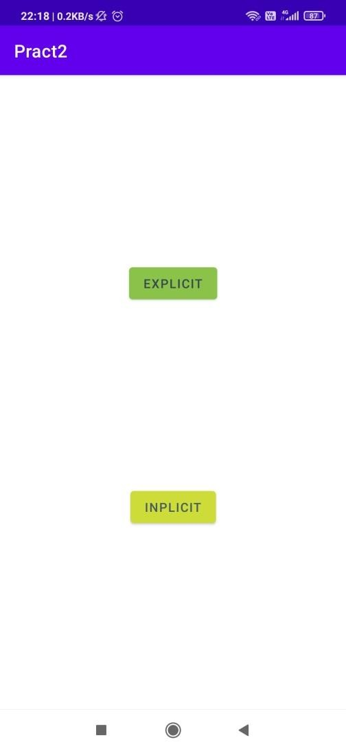

**Figure 1: Home Page**

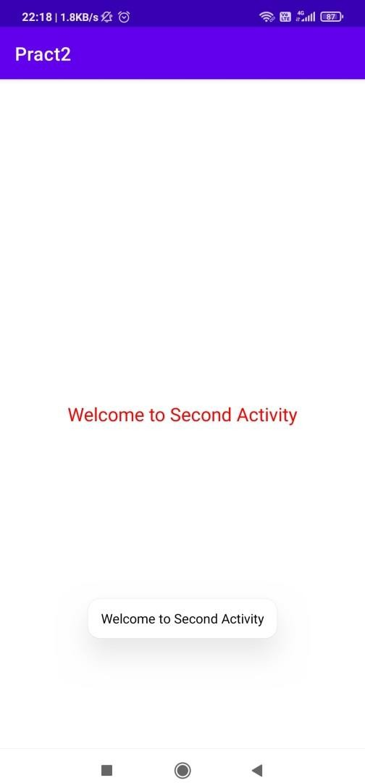 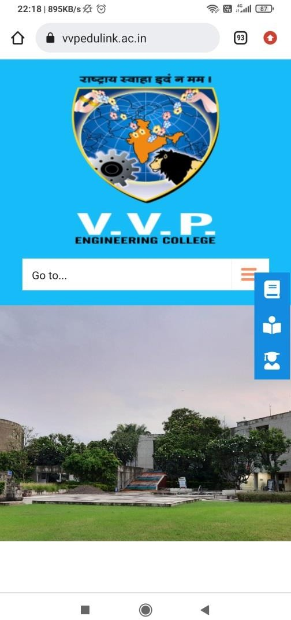

**Figure 2: On Clicking Explicit Figure 3: On Clicking Inplicit**